# Lab: Create a Web Service Client

1.

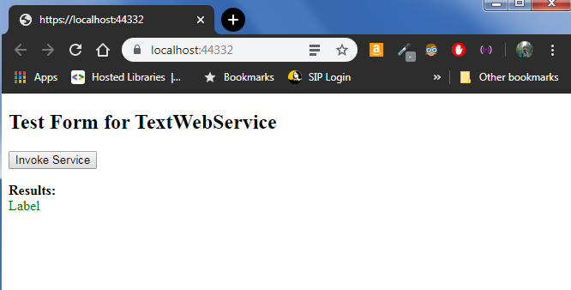

2.

# 